Coding Challenge -1

Car Rental System – SQL

Schema Creation:

1)Database creation:

**CREATE DATABASE CarRentalSystem;**

**use CarRentalSystem;**

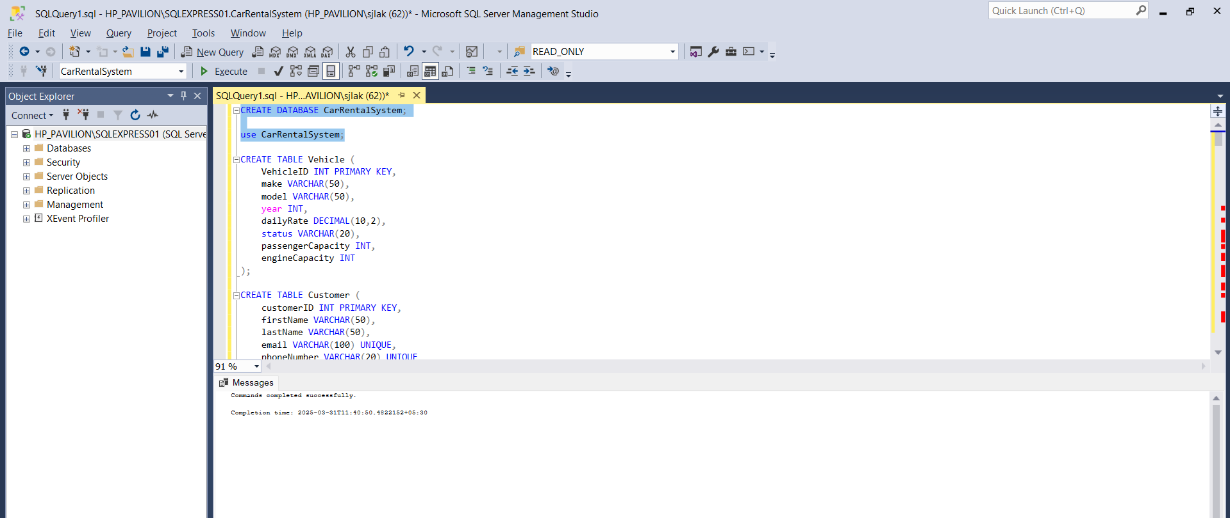

2) Creating Tables as per given schema:

**CREATE TABLE Vehicle (**

**VehicleID INT PRIMARY KEY,**

**make VARCHAR(50),**

**model VARCHAR(50),**

**year INT,**

**dailyRate DECIMAL(10,2),**

**status VARCHAR(20),**

**passengerCapacity INT,**

**engineCapacity INT**

**);**

**CREATE TABLE Customer (**

**customerID INT PRIMARY KEY,**

**firstName VARCHAR(50),**

**lastName VARCHAR(50),**

**email VARCHAR(100) UNIQUE,**

**phoneNumber VARCHAR(20) UNIQUE**

**);**

**CREATE TABLE Lease (**

**leaseID INT PRIMARY KEY,**

**vehicleID INT FOREIGN KEY REFERENCES Vehicle(vehicleID) ON DELETE CASCADE,**

**customerID INT FOREIGN KEY REFERENCES Customer(customerID) ON DELETE CASCADE,**

**startDate DATE,**

**endDate DATE,**

**type VARCHAR(20)**

**);**

**CREATE TABLE Payment (**

**paymentID INT PRIMARY KEY,**

**leaseID INT FOREIGN KEY REFERENCES Lease(leaseID) ON DELETE CASCADE,**

**paymentDate DATE,**

**amount DECIMAL(10,2)**

**);**

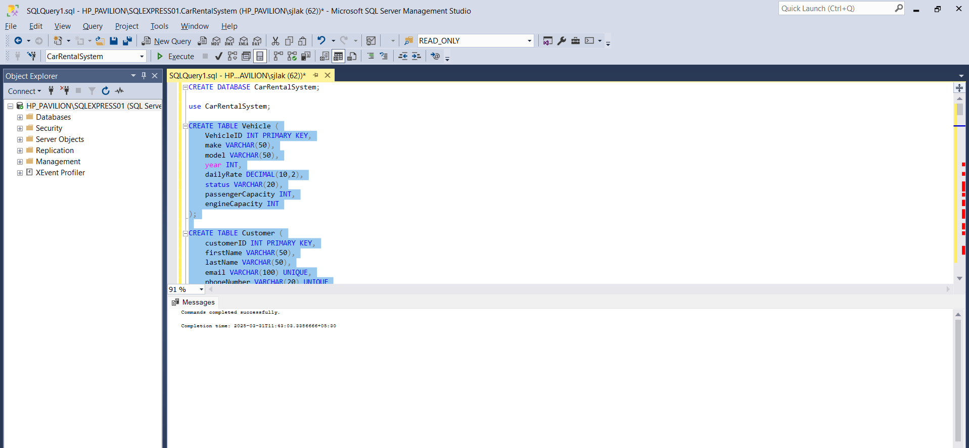

3) ADDING VALUES IN THE TABLE:

**INSERT INTO Vehicle VALUES**

**(1, 'Toyota', 'Camry', 2022, 50.00, 'available', 4, 1450),**

**(2, 'Honda', 'Civic', 2023, 45.00, 'available', 7, 1500),**

**(3, 'Ford', 'Focus', 2022, 48.00, 'notAvailable', 4, 1400),**

**(4, 'Nissan', 'Altima', 2023, 52.00, 'available', 7, 1200),**

**(5, 'Chevrolet', 'Malibu', 2022, 47.00, 'available', 4, 1800),**

**(6, 'Hyundai', 'Sonata', 2023, 49.00, 'notAvailable', 7, 1400),**

**(7, 'BMW', '3 Series', 2023, 60.00, 'available', 7, 2499),**

**(8, 'Mercedes', 'C-Class', 2022, 58.00, 'available', 8, 2599),**

**(9, 'Audi', 'A4', 2022, 55.00, 'notAvailable', 4, 2500),**

**(10, 'Lexus', 'ES', 2023, 54.00, 'available', 4, 2500);**

**SELECT * FROM Vehicle;**

**INSERT INTO Customer VALUES**

**(1, 'John', 'Doe', 'johndoe@example.com', '555-555-5555'),**

**(2, 'Jane', 'Smith', 'janesmith@example.com', '555-123-4567'),**

**(3, 'Robert', 'Johnson', 'robert@example.com', '555-789-1234'),**

**(4, 'Sarah', 'Brown', 'sarah@example.com', '555-456-7890'),**

**(5, 'David', 'Lee', 'david@example.com', '555-987-6543'),**

**(6, 'Laura', 'Hall', 'laura@example.com', '555-234-5678'),**

**(7, 'Michael', 'Davis', 'michael@example.com', '555-876-5432'),**

**(8, 'Emma', 'Wilson', 'emma@example.com', '555-432-1098'),**

**(9, 'William', 'Taylor', 'william@example.com', '555-321-6547'),**

**(10, 'Olivia', 'Adams', 'olivia@example.com', '555-765-4321');**

**SELECT * FROM Customer;**

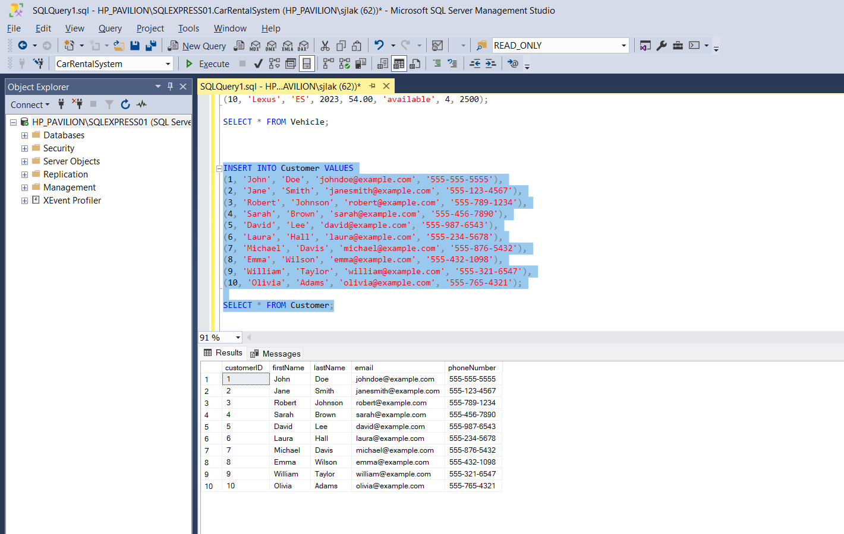

**INSERT INTO Lease VALUES**

**(1, 1, 1, '2023-01-01', '2023-01-05', 'Daily'),**

**(2, 2, 2, '2023-02-15', '2023-02-28', 'Monthly'),**

**(3, 3, 3, '2023-03-10', '2023-03-15', 'Daily'),**

**(4, 4, 4, '2023-04-20', '2023-04-30', 'Monthly'),**

**(5, 5, 5, '2023-05-05', '2023-05-10', 'Daily'),**

**(6, 4, 3, '2023-06-15', '2023-06-30', 'Monthly'),**

**(7, 7, 7, '2023-07-01', '2023-07-10', 'Daily'),**

**(8, 8, 8, '2023-08-12', '2023-08-15', 'Monthly'),**

**(9, 3, 3, '2023-09-07', '2023-09-10', 'Daily'),**

**(10, 10, 10, '2023-10-10', '2023-10-31', 'Monthly');**

**SELECT * FROM Lease;**

**INSERT INTO Payment VALUES**

**(1, 1, '2023-01-03', 200.00),**

**(2, 2, '2023-02-20', 1000.00),**

**(3, 3, '2023-03-12', 75.00),**

**(4, 4, '2023-04-25', 900.00),**

**(5, 5, '2023-05-07', 60.00),**

**(6, 6, '2023-06-18', 1200.00),**

**(7, 7, '2023-07-03', 40.00),**

**(8, 8, '2023-08-14', 1100.00),**

**(9, 9, '2023-09-09', 80.00),**

**(10, 10, '2023-10-25', 1500.00);**

**SELECT * FROM Payment;**

**Questions:**

--1. Update the daily rate for a Mercedes car to 68.

**UPDATE Vehicle SET dailyRate = 68.00**

**WHERE make = 'Mercedes';**

--2. Delete a specific customer and all associated leases and payments.

**DELETE FROM Customer WHERE customerID = 3;**

**SELECT * FROM Customer;**

--3.Rename the "paymentDate" column in the Payment table to "transactionDate".

**EXEC sp_rename 'Payment.paymentDate', 'transactionDate', 'COLUMN';**

--4. Find a specific customer by email.

**SELECT * FROM Customer WHERE email = 'sarah@example.com';**

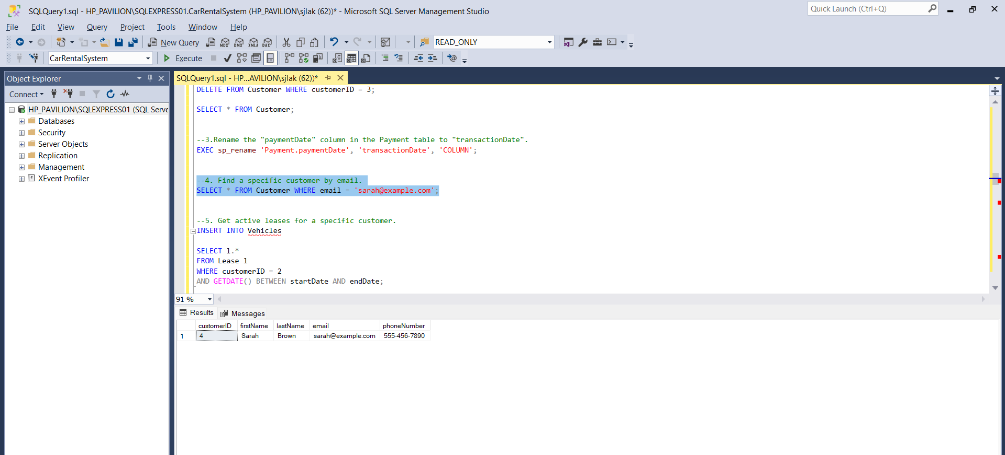

--5. Get active leases for a specific customer. (Here we don’t have any active leases so we are going to insert some values so that we can list them).

**INSERT INTO Vehicle VALUES**

**(11, 'Tesla', 'Model S', 2025, 80.00, 'available', 5, 0),**

**(12, 'Ford', 'Mustang', 2025, 75.00, 'available', 4, 5000),**

**(13, 'Chevrolet', 'Corvette', 2025, 85.00, 'available', 2, 6200);**

**INSERT INTO Customer VALUES**

**(11, 'Ram', 'Kumar', 'ram@example.com', '123-456-7890'),**

**(12, 'Harish', 'S', 'harishs@example.com', '103-456-7410'),**

**(13, 'Ryan', 'Miller', 'ryan.miller@example.com', '789-456-1230');**

**INSERT INTO Lease VALUES**

**(11, 11, 11, '2025-03-01', '2025-04-01', 'Monthly'),**

**(12, 12, 12, '2025-03-15', '2025-05-15', 'Monthly'),**

**(13, 13, 13, '2025-04-01', '2025-06-01', 'Monthly');**

**INSERT INTO Payment VALUES**

**(11, 11, '2025-03-05', 2400.00),**

**(12, 12, '2025-03-20', 3000.00),**

**(13, 13, '2025-04-05', 2550.00);**

**SELECT * FROM Lease WHERE customerID = 11 AND**

**GETDATE() BETWEEN startDate AND endDate;**

-- 6.Find all payments made by a customer with a specific phone number.

**select p.* from Payment p**

**INNER JOIN Lease l ON p.leaseID = l.leaseID**

**INNER JOIN Customer c ON l.customerID = c.customerID**

**where c.phoneNumber = '555-456-7890';**

--7. Calculate the average daily rate of all available cars.

**SELECT AVG(dailyRate) AS AverageDailyRate**

**FROM Vehicle**

**WHERE status = 'available';**

--8. Find the car with the highest daily rate.

**SELECT TOP 1 * FROM Vehicle ORDER BY dailyRate DESC;**

--9. Retrieve all cars leased by a specific customer.

**SELECT V.* FROM Vehicle V**

**JOIN Lease L ON V.vehicleID = L.vehicleID**

**WHERE L.customerID = 12;**

--10. Find the details of the most recent lease.

**SELECT TOP 1 * FROM Lease ORDER BY endDate DESC;**

--11. List all payments made in the year 2023.

**SELECT * FROM Payment WHERE YEAR(transactionDate) = 2023;**

--12. Retrieve customers who have not made any payments.

**SELECT c.* FROM Customer c**

**LEFT JOIN Lease l ON c.customerID = l.customerID**

**LEFT JOIN Payment p ON l.leaseID = p.leaseID**

**WHERE p.paymentID IS NULL;**

--13.Retrieve Car Details and Their Total Payments.

**SELECT V.vehicleID, V.make, V.model, SUM(P.amount) AS TotalPayment FROM Vehicle V**

**JOIN Lease L ON V.vehicleID = L.vehicleID**

**JOIN Payment P ON L.leaseID = P.leaseID**

**GROUP BY V.vehicleID, V.make, V.model;**

--14.Calculate Total Payments for Each Customer.

**SELECT C.customerID, C.firstName, C.lastName, SUM(P.amount) AS totalPayments FROM Customer C**

**JOIN Lease L ON C.customerID = L.customerID**

**JOIN Payment P ON L.leaseID = P.leaseID**

**GROUP BY C.customerID, C.firstName, C.lastName;**

--15. List Car Details for Each Lease.

**SELECT L.leaseID, C.firstName, C.lastName, V.make, V.model, L.startDate, L.endDate FROM Lease L**

**JOIN Customer C ON L.customerID = C.customerID**

**JOIN Vehicle V ON L.vehicleID = V.vehicleID;**

**--16. Retrieve Details of Active Leases with Customer and Car Information.**

**SELECT L.leaseID, C.firstName, C.lastName, V.make, V.model, L.startDate, L.endDate FROM Lease L**

**JOIN Customer C ON L.customerID = C.customerID**

**JOIN Vehicle V ON L.vehicleID = V.vehicleID**

**WHERE GETDATE() BETWEEN l.startDate AND l.endDate;**

--17. Find the Customer Who Has Spent the Most on Leases

**SELECT TOP 1 C.customerID, C.firstName, C.lastName, SUM(P.amount) AS totalSpent FROM Customer C**

**JOIN Lease L ON C.customerID = L.customerID**

**JOIN Payment P ON L.leaseID = P.leaseID**

**GROUP BY C.customerID, C.firstName, C.lastName**

**ORDER BY totalSpent DESC;**

--18.List All Cars with Their Current Lease Information

**SELECT V.vehicleID, V.make, V.model, L.leaseID, L.startDate, L.endDate, L.type FROM Vehicle V**

**LEFT JOIN Lease L ON V.vehicleID = L.vehicleID**

**ORDER BY V.vehicleID;**

